1. Write a program to calculate the bill of a cellular service customer depending upon on his/her usage. The following calculates ‘Bill’ as per ‘Usage’ with the following rules applicable. If ‘Bill’ is more than $100, 10% discount is given. Perform data flow testing for all variables. Determine the output using test suite for variables.

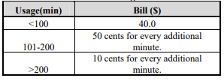

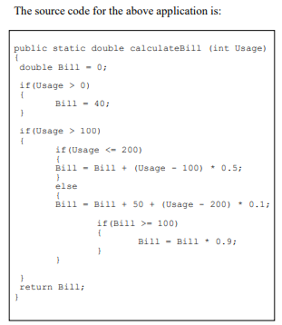

**Steps for Data Flow Testing**

1. Write a Data Flow Graph for the given code
2. Prepare Definition and Usage table for all the variables of the program
3. Prepare DU-Pair table using Definition and Usage table.
4. Find the test suite for the below criterias
   * All-defs
   * All-c-uses
   * All-p-uses
   * All-p-uses/some-c-uses
   * All-c-uses/some-p-uses
   * All-uses
   * All-du-paths
5. Execute the test cases for the selected du-pair for the above criteria’s by giving input for the variable.

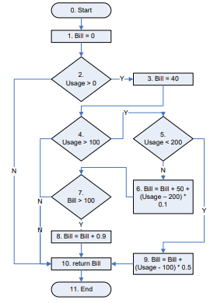

|  |  |  |  |
| --- | --- | --- | --- |
| **Definition Usage Table** | | | |
| Variable | Definition Node | C-Use | P-Use |
| Bill |  |  |  |
|  |  |  |
|  |  |  |

|  |  |  |
| --- | --- | --- |
| **DU-Pair Table** | | |
| Variable | C-Use | P-Use |
| Bill |  |  |
|  |  |
|  |  |

**Test Suite for variable ‘Bill’**

|  |  |  |  |  |  |  |
| --- | --- | --- | --- | --- | --- | --- |
| Uses | DU-Pair | Paths | Input Usage Value for Bill | Expected Output | Actual Output | Status |
| All Definition (AD) |  |  |  |  |  |  |
|  |  |  |  |  |  |
|  |  |  |  |  |  |
|  |  |  |  |  |  |
|  |  |  |  |  |  |
| All c-uses (ACU) |  |  |  |  |  |  |
|  |  |  |  |  |  |
|  |  |  |  |  |  |
|  |  |  |  |  |  |
|  |  |  |  |  |  |
| All p-uses (APU) |  |  |  |  |  |  |
|  |  |  |  |  |  |
|  |  |  |  |  |  |
| All c-use/some p-use |  |  |  |  |  |  |
|  |  |  |  |  |  |
|  |  |  |  |  |  |
|  |  |  |  |  |  |
|  |  |  |  |  |  |
|  |  |  |  |  |  |
| All p-use/some c-use |  |  |  |  |  |  |
|  |  |  |  |  |  |
|  |  |  |  |  |  |
|  |  |  |  |  |  |
|  |  |  |  |  |  |
| All Uses(AU) |  |  |  |  |  |  |
|  |  |  |  |  |  |
|  |  |  |  |  |  |
|  |  |  |  |  |  |
|  |  |  |  |  |  |